PROJECT DESIGN PHASE
Solution Architecture
Automated Network Request Management System
Student Name | Bantupalli Niharika | Date | 5 September 2026
Project Phase | Project Design | Platform | ServiceNow

1. Solution Overview
The proposed solution uses ServiceNow to provide a structured, traceable workflow for network-related service requests. Employees submit requests through the Service Portal. The catalog form captures the required details, while client-side controls and validation rules improve data quality. Flow Designer coordinates approvals and fulfilment activities, assigns work to the Network Support Group, and tracks progress through request and task records.

2. High-Level Architecture
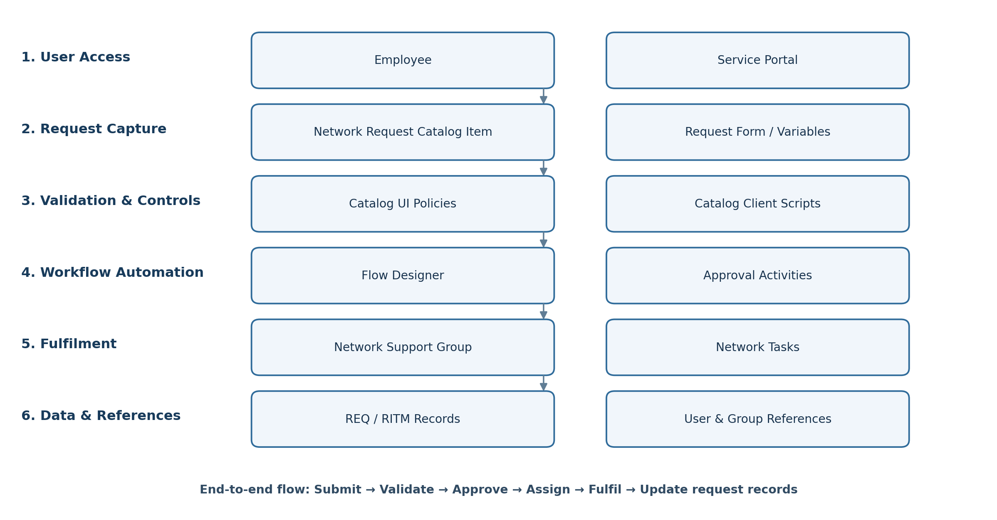
Figure 1. High-level ServiceNow architecture for the Automated Network Request Management System.

3. Component Responsibilities
Architecture layer | ServiceNow components | Purpose
Experience | Service Portal | Provides the employee-facing entry point.
Request capture | Network Request Catalog Item; catalog variables | Captures network request details in a standard format.
Interaction | Catalog Client Scripts; UI Actions (where used) | Supports form behaviour and user interaction.
Validation | Catalog UI Policies; Client Scripts; server-side validation (as required) | Controls fields and helps prevent incomplete or invalid submissions.
Automation | Flow Designer; approval actions | Routes approvals and coordinates fulfilment.
Fulfilment | Network Support Group; fulfilment tasks | Enables assignment, execution and status tracking.
Data | REQ; RITM; task records | Maintains request and fulfilment history.
Reference data | sys_user; sys_user_group | Provides user and group information for ownership and routing.

4. End-to-End Request Processing
1. User access — Employees access the Service Portal and open the Network Request Catalog Item.
2. Request capture — The catalog item collects the required network request information through form variables.
3. Validation and form behaviour — Catalog UI Policies and Catalog Client Scripts control field visibility, mandatory status, read-only behaviour and client-side checks. Server-side validation should be used where data integrity or security requires it.
4. Workflow and approvals — Flow Designer evaluates the request, routes it for the required approvals and starts the fulfilment process after approval.
5. Fulfilment — The workflow creates or routes fulfilment work to the Network Support Group. Support staff update task status and record completion details.
6. Data and traceability — ServiceNow maintains the request lifecycle through REQ and RITM records and associated fulfilment task records. User and group reference data supports assignment and routing.

5. Design Clarifications and Improvements
Terminology alignment: The source diagram showed both a Catalog Item and a Record Producer. These are different ServiceNow mechanisms. This revised architecture uses a Catalog Item as the request-entry mechanism, consistent with the source table's REQ/RITM model. A Record Producer should be shown only if the implemented solution actually uses one to create a target-table record.
Record naming: Use “fulfilment task records” as the generic term unless the implementation confirms a specific task table. Do not label every task as a custom “Network Tasks” table unless that table has actually been created.
Validation placement: UI Policies and Catalog Client Scripts improve the form experience, but important business rules and access checks should also be enforced server-side where applicable.
Workflow outcome: The exact approval conditions, assignment rules, task fields and completion states should match the configured Flow Designer flow in the implemented application.

6. Expected Design Benefits
- Standardized request submission through a single employee-facing portal.
- Improved data quality through clear form controls and validation.
- Consistent approval routing and coordinated fulfilment using Flow Designer.
- Clear task ownership and progress visibility for the Network Support Group.
- Traceable request history through linked request, item and task records.

